**Programming Paradigms Laboratory**

**B.Tech.**



**Name : Tanishq Porwar**

**Roll Number : 18ETCS002131**

**Department : Computer Science and Engineering**

**Faculty of Engineering & Technology**

**Ramaiah University of Applied Sciences**

|  |  |
| --- | --- |
| Faculty | Engineering & Technology |
| Programme | B. Tech. in Computer Science and Engineering |
| Year/Semester | 2nd Year / 4th Semester |
| Name of the Laboratory | Programming Paradigms Laboratory |
| Laboratory Code | 19CSL217A |

# Laboratory 6

Title of the Laboratory Exercise: Inheritance

1. Questions
2. Develop a java application to implement educational hierarchy using inheritance

|  |
| --- |
| Office |
| empno:  empname:  salary:  getvalue() |

Non-Teaching

Designation:

setvalue()

Teaching

Designation:

setvalue()

1. Develop a Java program to create an class shape. Let rectangle and triangle inherit this shape class. Add necessary functions.
2. Calculations/Computations/Algorithms

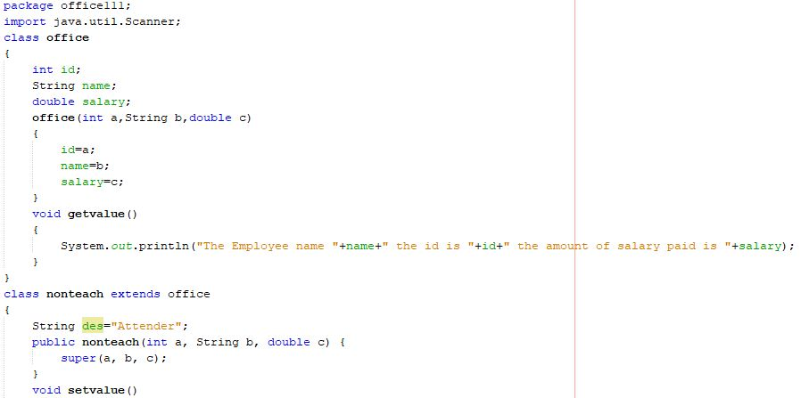

Fig1.1

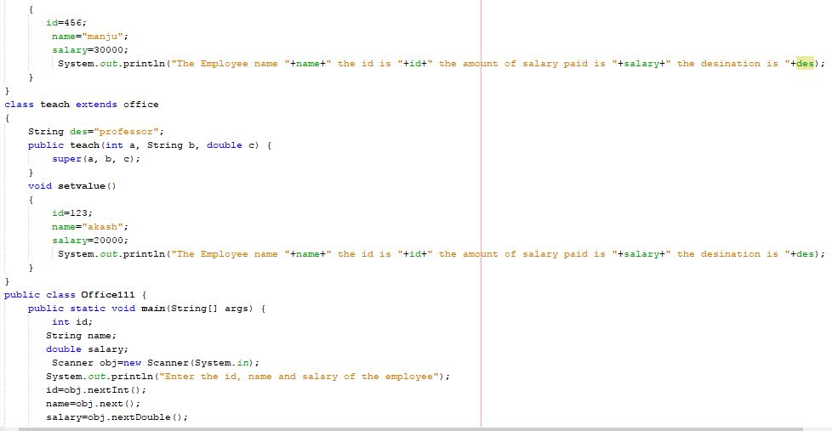

Fig1.2

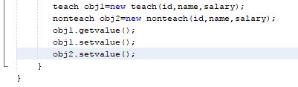

Fig1.3

Fig 1.1, 1.2, 1.3 Represents the java program to implement educational hierarchy using inheritance

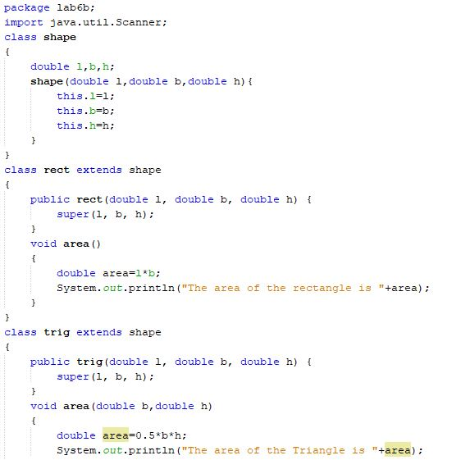

Fig2.1

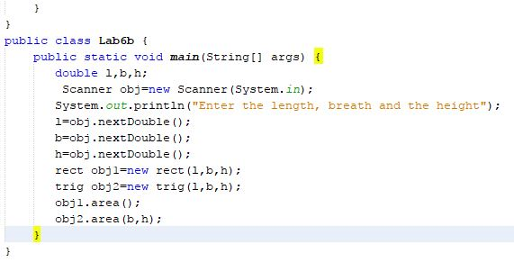

Fig2.2

Fig 2.1, 2.2 Represents the java program to create a class shape. Let rectangle and triangle inherit this shape class. Add necessary functions.

1. Presentation of Results

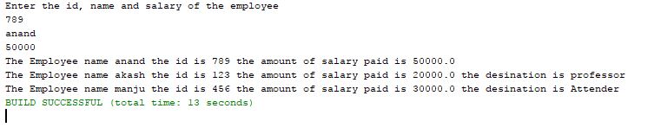

Fig 1.4 represents the output of the java program to implement educational hierarchy using inheritance

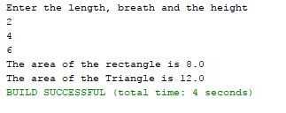

Fig 2.3 represents the output of the java program to create a class shape. Let rectangle and triangle inherit this shape class. Add necessary functions.

1. Conclusions

We have learned how to do the inheritance for the java program and how the inherit concept works and abstract class in the program to know how it will work and its interaction between 2 or more class.

1. Limitations of Experiments and Results

The objects should be given to the child class of the abstract class as it is inherited.